Brian Engel

Module 2 Assignment

1.

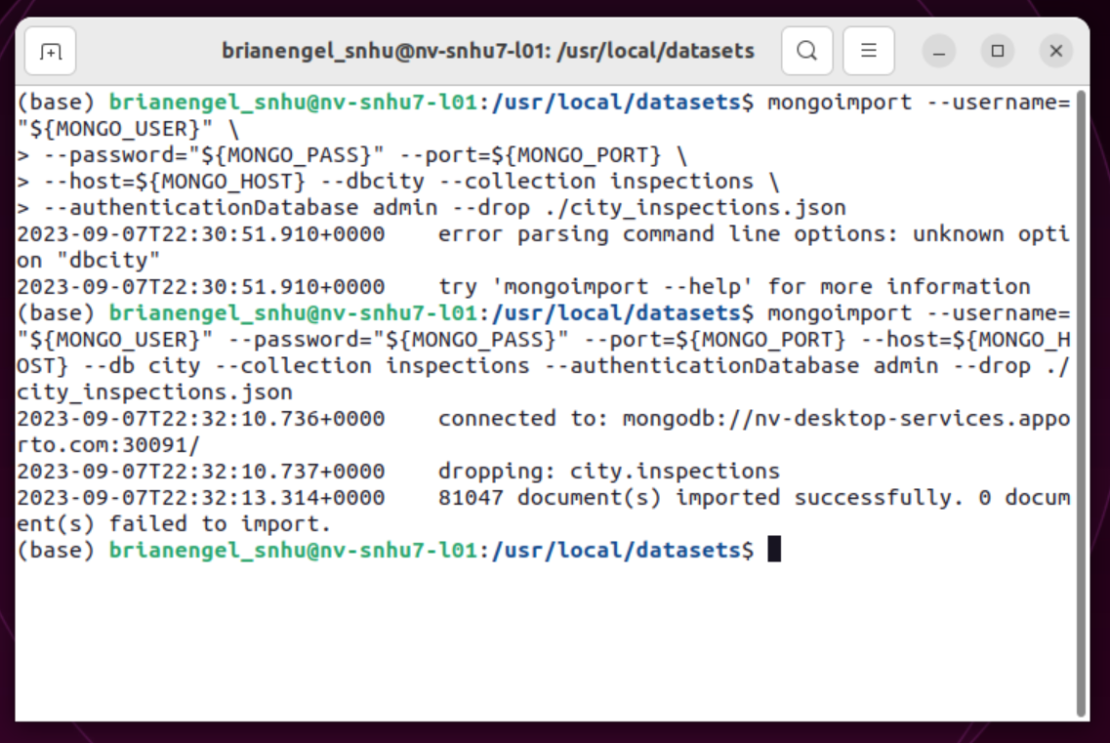

There is a typo in the instructions on the import showing to type --dbcity instead of --db city

2. use city

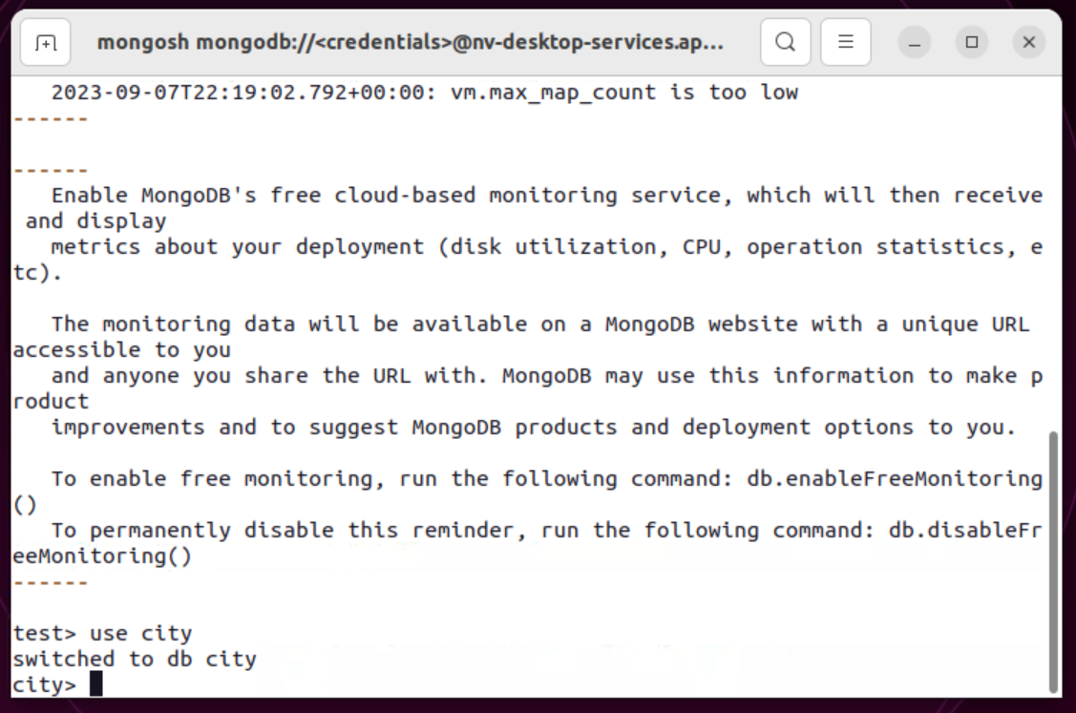

db.inspections.find({"id" : "10021-2015-ENFO"})

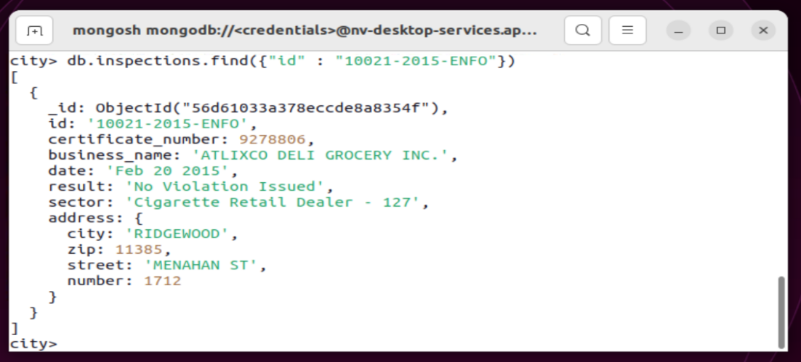

db.inspections.find({"result":"Out of Business"},{"business_name":1}).limit(10)

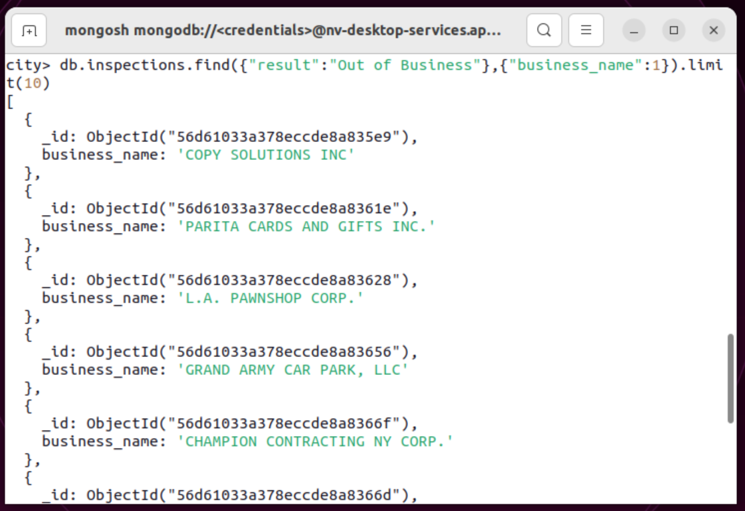

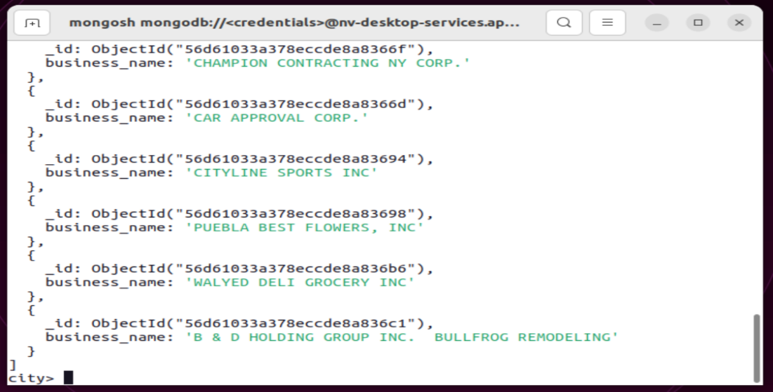

3. insertOne

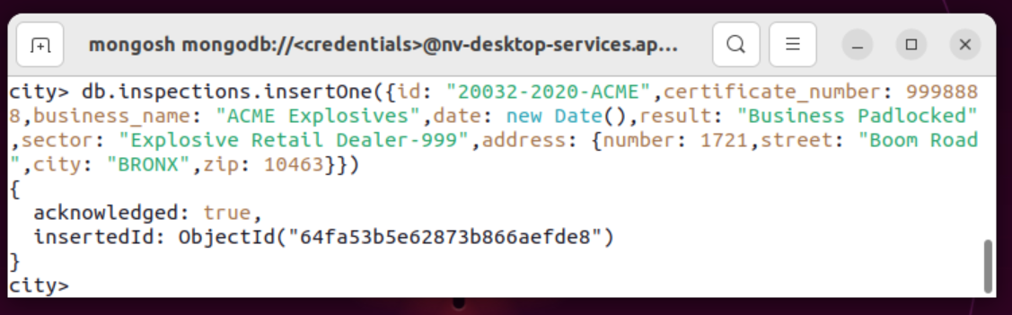

findOne

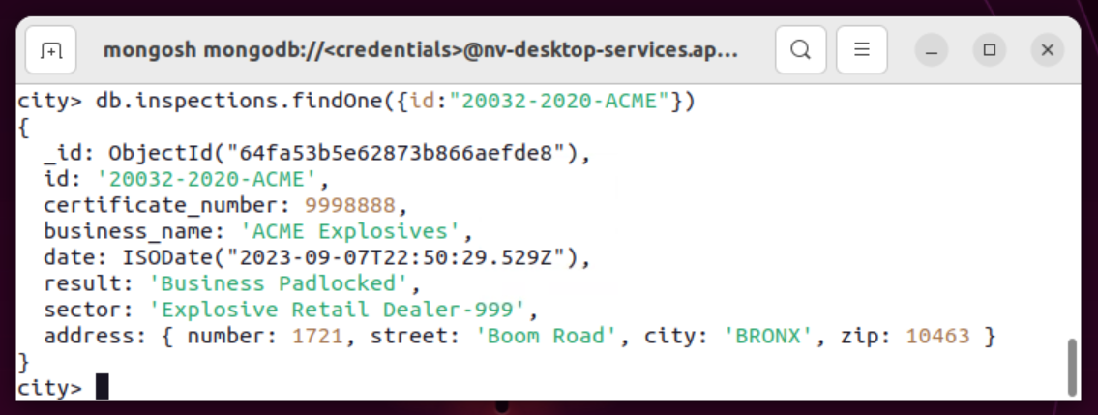

4. What is the distinct list of inspection “sector” in the current inspections collection?

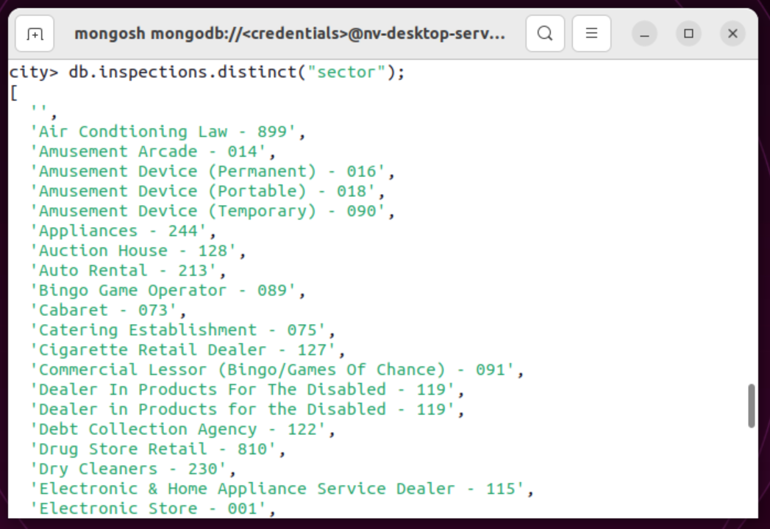

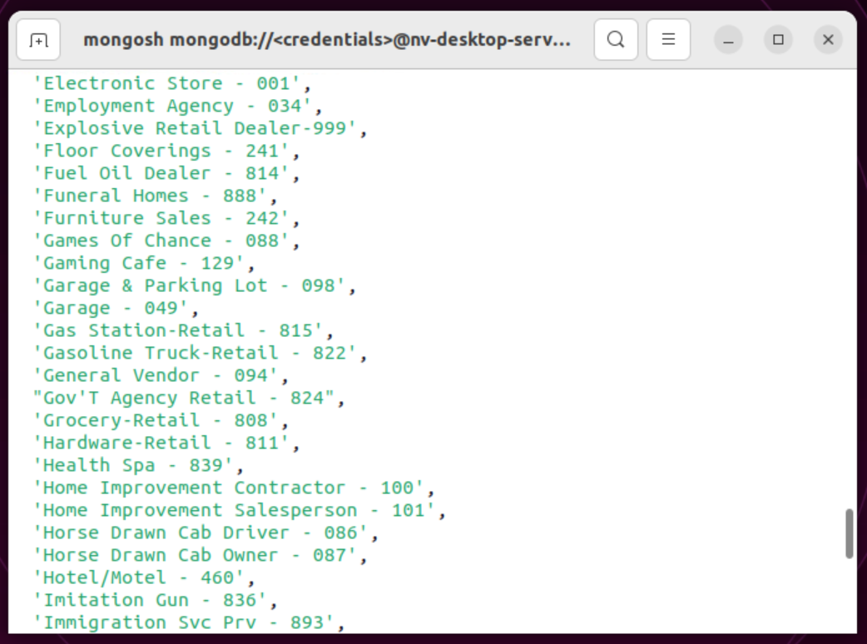

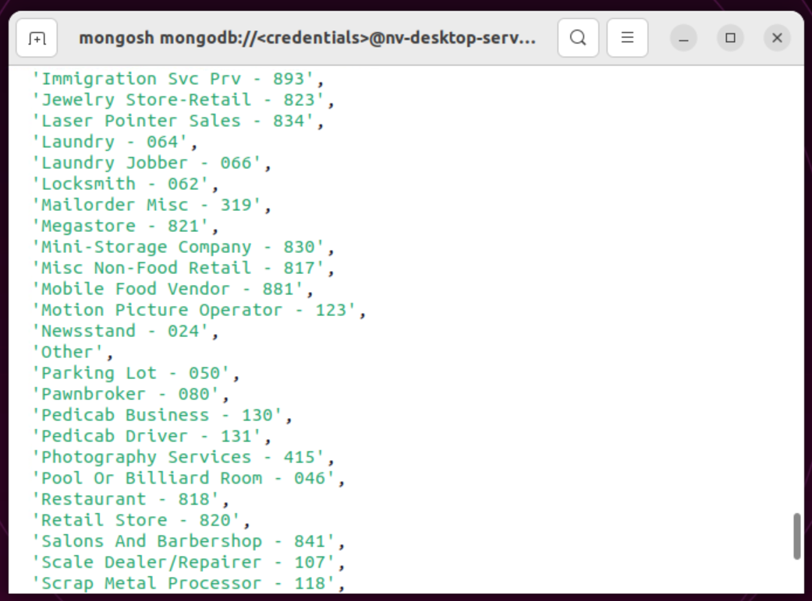

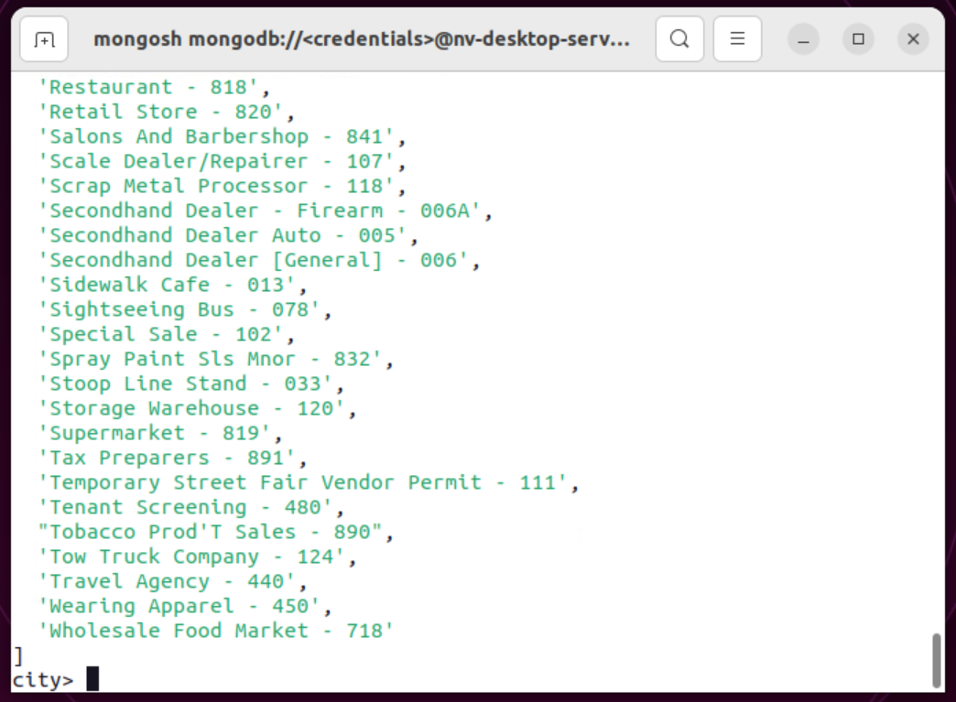

How many are in the list? Do not count by hand.

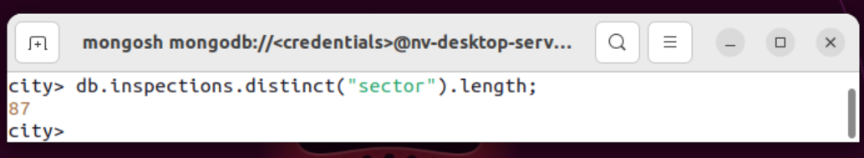

This returns the length of the array from the step before. I noticed there is a blank spot in the array at index 0 so if that is not supposed to be counted to would be 86 instead of 87.

What is the difference in the date data type for the business named “AUSTIN 2012” versus your business document insertion of “Acme Explosives”?

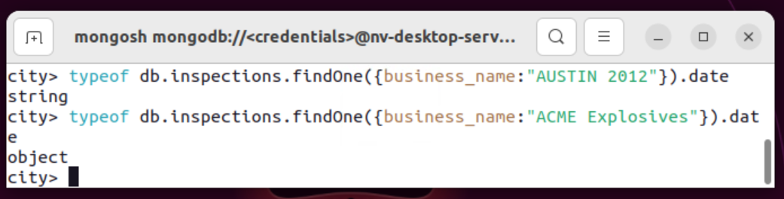

Using the date function created an object. The other date was just a string.

How many businesses have a “Violation Issued”?

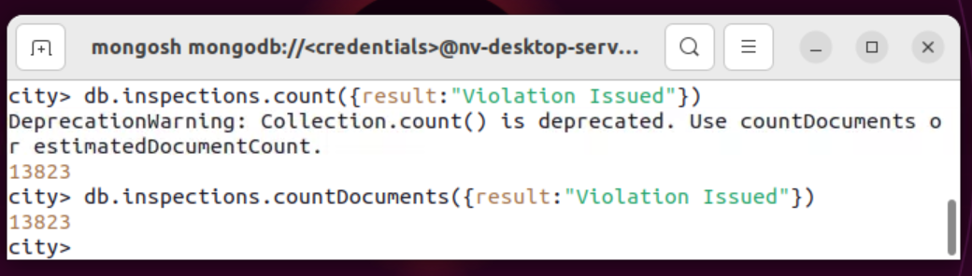

5. current value for 200023-2020-ACME

Updating 200023-2020-ACME

Value after update

6. Update all the documents that contain the key-value pair "city":"ROSEDALE" in the address subdocument by changing the zip code in the address subdocument to "76114".

First screen only changed one so I redid it with updateMany.

Documents afterward (just first 3)

Remove the first document with the key-value pair "result":"Violation Issued."

It will remove the first document which should be this one:

Delete document

Got the count of documents with the id to verify it is gone.

